**MySQL + Info-Gathering:**

**CMF - MySQL Server Info-Gathering Automation for Linux - User Guide**

**For Script:**

**CMF-MySQL-Linux.ps1**



**Document Summary**

|  |  |
| --- | --- |
| **Document Item** | **Current Value** |
| Document Title | MySQL Server Automation User Guide |
| Program | CSU Migration Factory |
| Date Last Modified | 05-Oct-2023 |
| Date Last Reviewed | 05-Oct-2023 |
| Current Document Known Issue | N/A |
| Status | Initial |
| Document Description | This document provides the procedure/steps to execute the Automation script which gathers the MySQL server details. |

**Revision History**

This section represents the change history of the document. Revisions of the document must be tracked by identifying a new version number, the date it was modified, the person making the change, and the reason for the change.

|  |  |  |  |  |
| --- | --- | --- | --- | --- |
| Date | Version | Change Description | Author | Reviewer |
| 5-Oct-2023 | 1.0 | Initial Version | Lekshmy, Arun, Mukesh, Chethan | Rackimuthu Kandaswamy |
| 04-Dec-2023 | 1.1 | Added SSL Mode | Lekshmy, Arun, Mukesh, Chethan | Sharad Khadtare,  Rackimuthu Kandaswamy |

Contents

1. Executive Summary 4

1.1 Objective 4

1.2 Recommendations 4

2 Executing the Script 4

2.1 MySQL Server Automation execution 4

2.2 Create a folder named MySQL-Info-Gather 5

2.3 Copy all the provided files to this folder(MySQL-Info-Gather) as shown below… 5

2.4 Renaming Scripts 5

2.5 Enter the following command to execute the script. 5

2.5.1 Creation of supporting folders(Logs, Output, Downloads etc) and Validate ImportExcel Module automatically… 6

2.6 Export Info-Gathering details and generating Output log files 7

2.7 Automation Script Transcript Log 8

3 Prerequisites for MySQL Server Automation - Execution. 9

Input Excel File 9

3.1 PowerShell Installation on Linux 10

4 Preparing the INPUT CSV File 10

Input File - **CMF-MySQL_Server_Input_file.csv** CSV File 11

# Executive Summary

## Objective

This document provides the procedure/steps to execute the Automation script (CMF-MySQL-Linux.ps1) which gathers the MySQL Server details from Linux environment.

Note: The values present in the Screenshots are demo values. Please change the values as Appropriate.

## Recommendations

Key recommendations are as follows:

1. Connectivity must exist between the SYSTEM which runs the MySQL Single Info Gathering Automation script
2. Powershell 5.1 version and above.

# Executing the Script

## MySQL Server Automation execution

* Open Putty, connect to the server and execute the script.

## Create a folder named MySQL-Info-Gather

image

## 2.3 Copy all the provided files to this folder(MySQL-Info-Gather) as shown below…

## 2.4 Renaming Scripts

* Execute the following command in Info-Gather folder to rename the scripts from .txt to .ps1

**sh rename-linux.txt**

## Enter the following command to execute the script.

**pwsh ./CMF-MySQL-Linux.ps1**

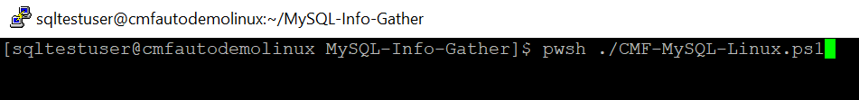

### Creation of supporting folders (Logs, Output, Downloads etc) and Validate prerequisite Module.

**Note:** After triggering the automation all the support folders (Logs, Output, Downloads etc.) will be created automatically by the automation script, Mysql path is validated, and it will ask user to proceed with the execution of the script.

The script then Validates the list of Hosts to proceed with execution. Continue by Entering “Y” and provide your **Project Name**. You’ll get below Final Status of the Script Execution.

* List of the Hosts the automation will proceed based on the user selection.

* Next, enter “Y” to proceed MySQL server Info-Gathering.

* Final Execution

## Export Info-Gathering details and generating Output log files

Output log files are generated for each MySQL Server as shown in the below Output Folder.

## Automation Script Transcript Log

**Note:** For the Automation, transcript will be generated in text format as above

(.\Logs\ CMF_MySQL_Server_Info_Gathering_Automation_Transcript_*.txt)

Please Share the Compressed Output and Logs Folder with the CMF Team for further review.

# Prerequisites for MySQL Server Automation - Execution.

## 

## Input Excel File

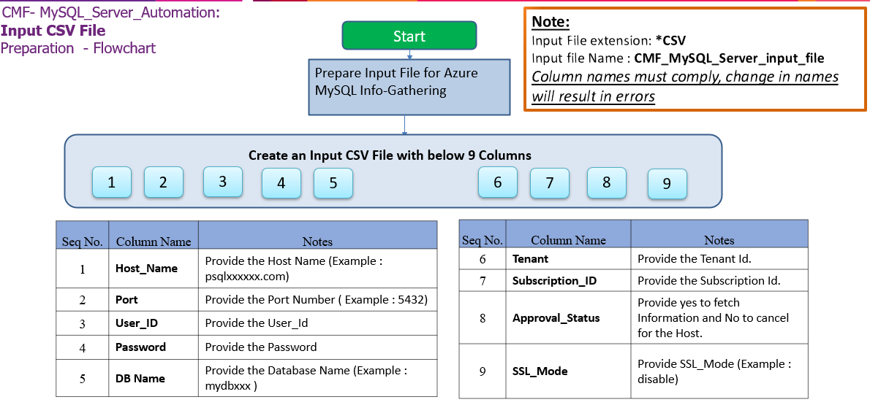

**Important Notes:**

* MySQL Client is required to establish Connectivity to MySQL Servers.
* This script is based on the CSV file named   
  ‘**CMF-MySQL_Server_Input_file.csv**’.
* **Column Name must be kept as shown below, change in names will result in errors**
* **Values in the column must be correct, incorrect values will also result in errors**
* **Tenant and Subscription_ID columns are Optional.**

1. **Columns for Input File: CMF-MySQL_Server_Input_file.csv**

|  |  |
| --- | --- |
| **Column Name** | **Note** |
| **Host_Name** | Provide the Host Name (Example : localhost) |
| **Port** | Provide the Port Number ( Example : 5432) |
| **VCore** | Provide the Number of VCore (Optional) |
| **Auth_Type** | Provide the Authentication Type(Optional) |
| **User_ID** | Provide the User_Id |
| **Password** | Provide the Password |
| **DB_Name** | Provide the Database Name (Example : MySQL ) |
| **Tenant** | Provide the Tenant Id. (Optional) |
| **Subscription_ID** | Provide the Subscription Id. (Optional) |
| **Approval_Status** | Provide yes to fetch Information and No to cancel for the Host. |
| **SSL_Mode** | Provide SSL_Mode (Example : disable) |

|  |  |  |
| --- | --- | --- |
| **Seq.No** | **File** | **Note** |
| 1 |  | Sample: **CMF-MySQL_Server_Input_file.csv** |

## PowerShell Installation on Linux

|  |
| --- |
| # Register the Microsoft RedHat repository  curl https://packages.microsoft.com/config/rhel/7/prod.repo | sudo tee /etc/yum.repos.d/microsoft.repo  # Install PowerShell  sudo yum install –assume yes powershell  # Start PowerShell  Pwsh |

# Preparing the INPUT CSV File

In Order to support the Info Gathering process, INPUT CSV FILE (**CMF-MySQL_Server_Input_file.csv**) should be provided with MySQL Server details.

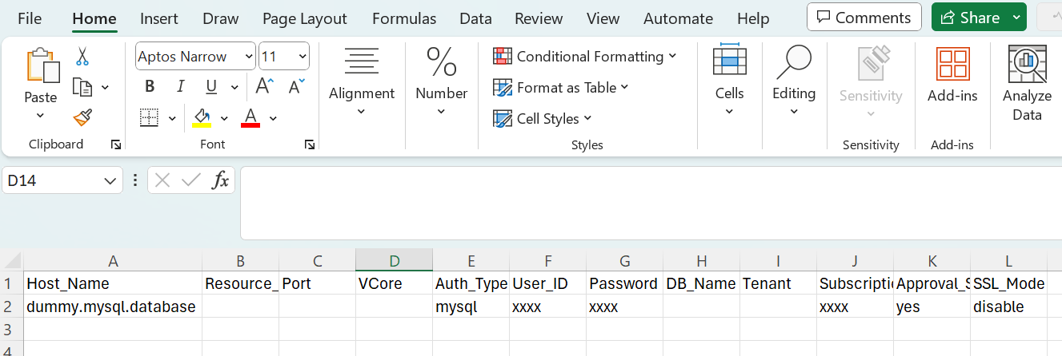

## Input File - **CMF-MySQL_Server_Input_file.csv** CSV File

|  |  |  |  |
| --- | --- | --- | --- |
| **Columns** | **Sample value** | **Mandatory** | **Description** |
| Host_Name | test-single-server | Yes | The name or resource ID of the source Azure Database for MySQL Single Server. |
| Resource_Group | test-rg | Yes | The name of the Azure resource group of the source Azure Database for MySQL Single Server. |
| Port | 3306 | No | Port number of MySQL, not require if default port 3306 |
| VCore | 2 | No | The number of vCores of the Source Azure Database for MySQL Single Server |
| Auth_Type | mysql | No | database auth type |
| User_ID | adminuser | Yes | The username for the administrator sign-in for your Source Azure Database for MySQL Single Server. |
| Password | password | Yes | The Password for the administrator sign-in for your Source Azure Database for MySQL Single Server. |
| DB_Name | mysql | No | database Name |
| Tenant | test.onmicrosoft.com | No | tenant Id |
| Subscription_ID | edf6dd9d-****-4bca-a997-***** | No | subscription_id |
| Approval_Status | No | Yes | Approved to migrate - Yes/No. |
| SSL_Mode | PREFERRED | yes | ssl_mode Id – Preferred |